Hexagonal Bipyramid

Definition
# Source: AI Source: Provided by: [Data Path: Persons Table -> ID Column: 1, Name_En Column: Motasem Essam] -> From: [ChatGPT] on [7/25/2026]
A Hexagonal Bipyramid is a three-dimensional polyhedron formed by joining two hexagonal pyramids at their congruent hexagonal bases. The shared hexagonal base becomes an internal face, while the triangular lateral faces form the exterior surface.
It consists of:
- Two apexes positioned on opposite sides of a common hexagonal base.
- Six vertices forming the shared hexagonal base.
- Twelve external triangular faces.
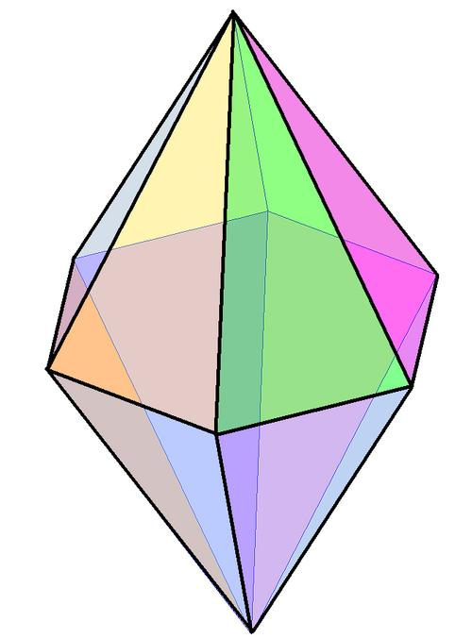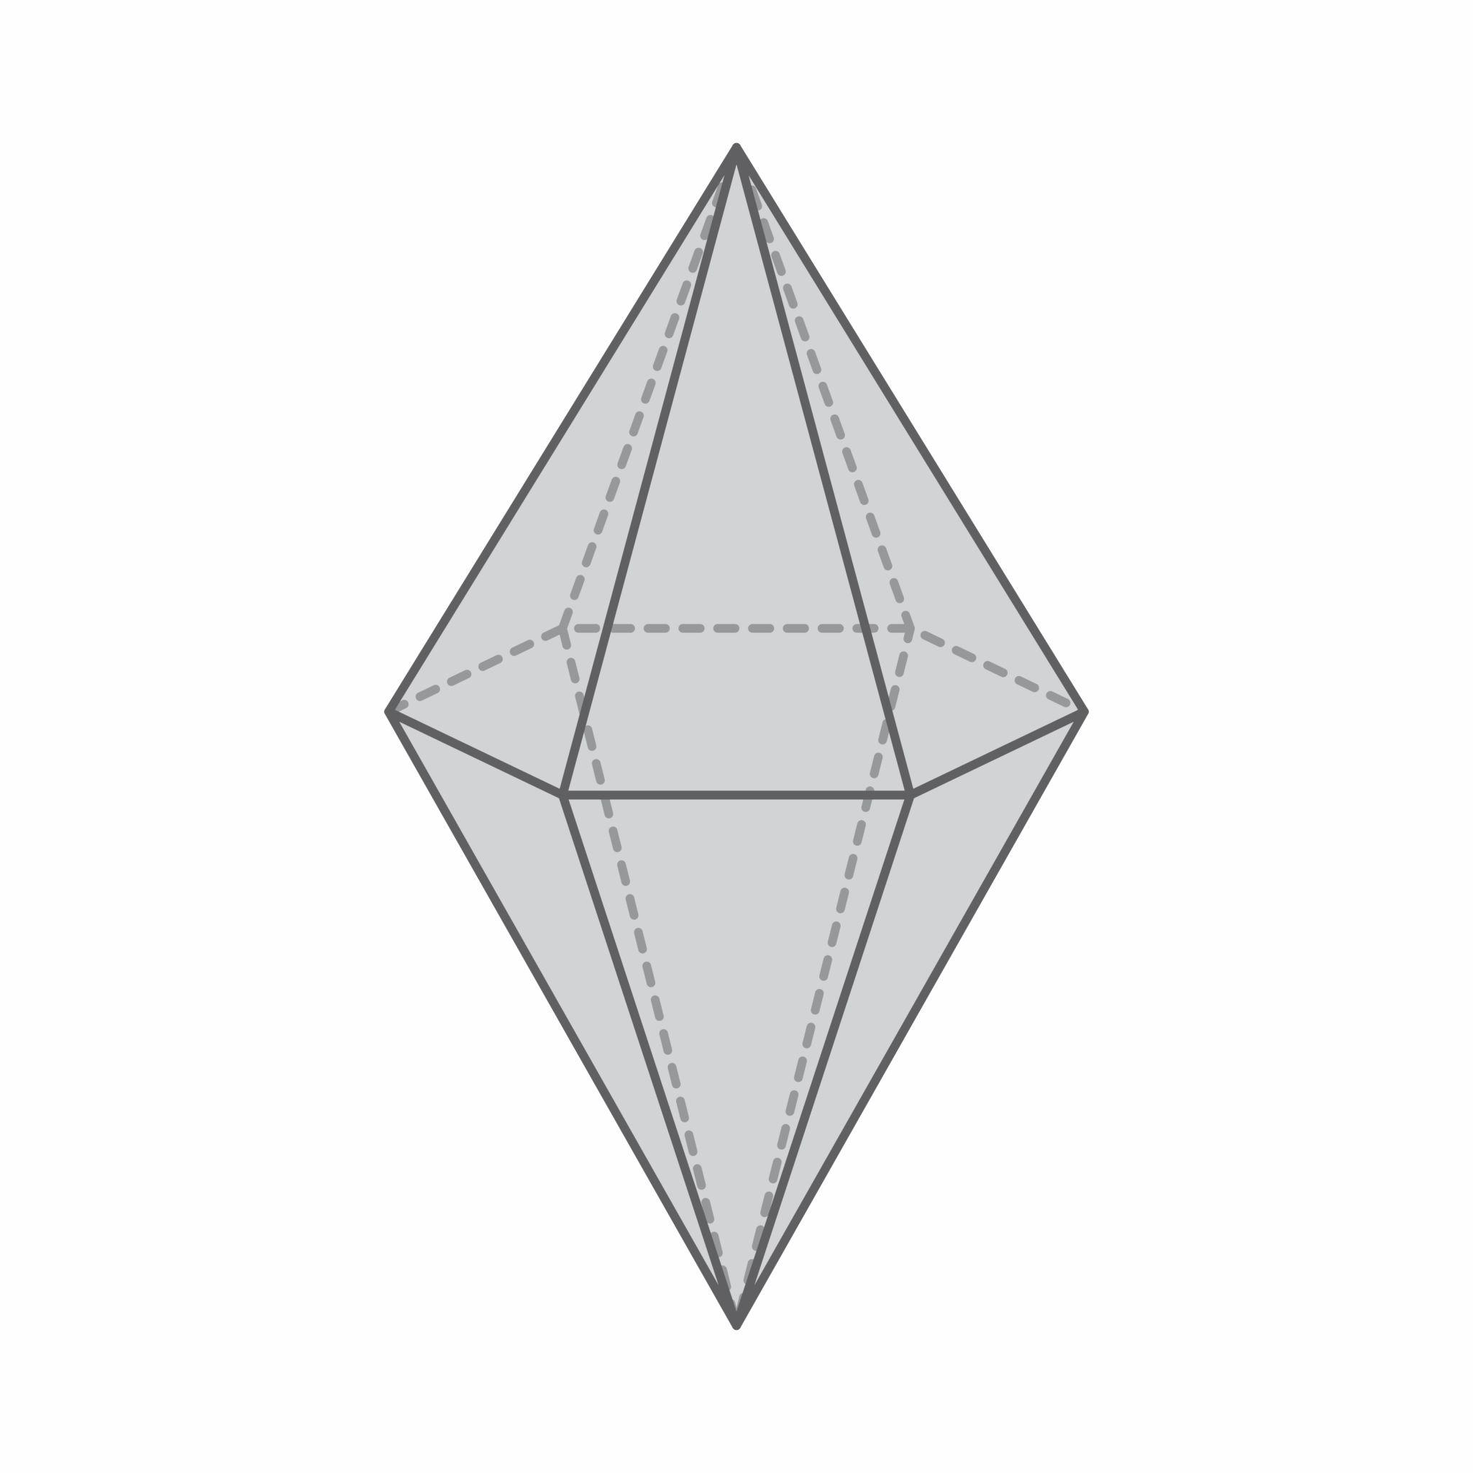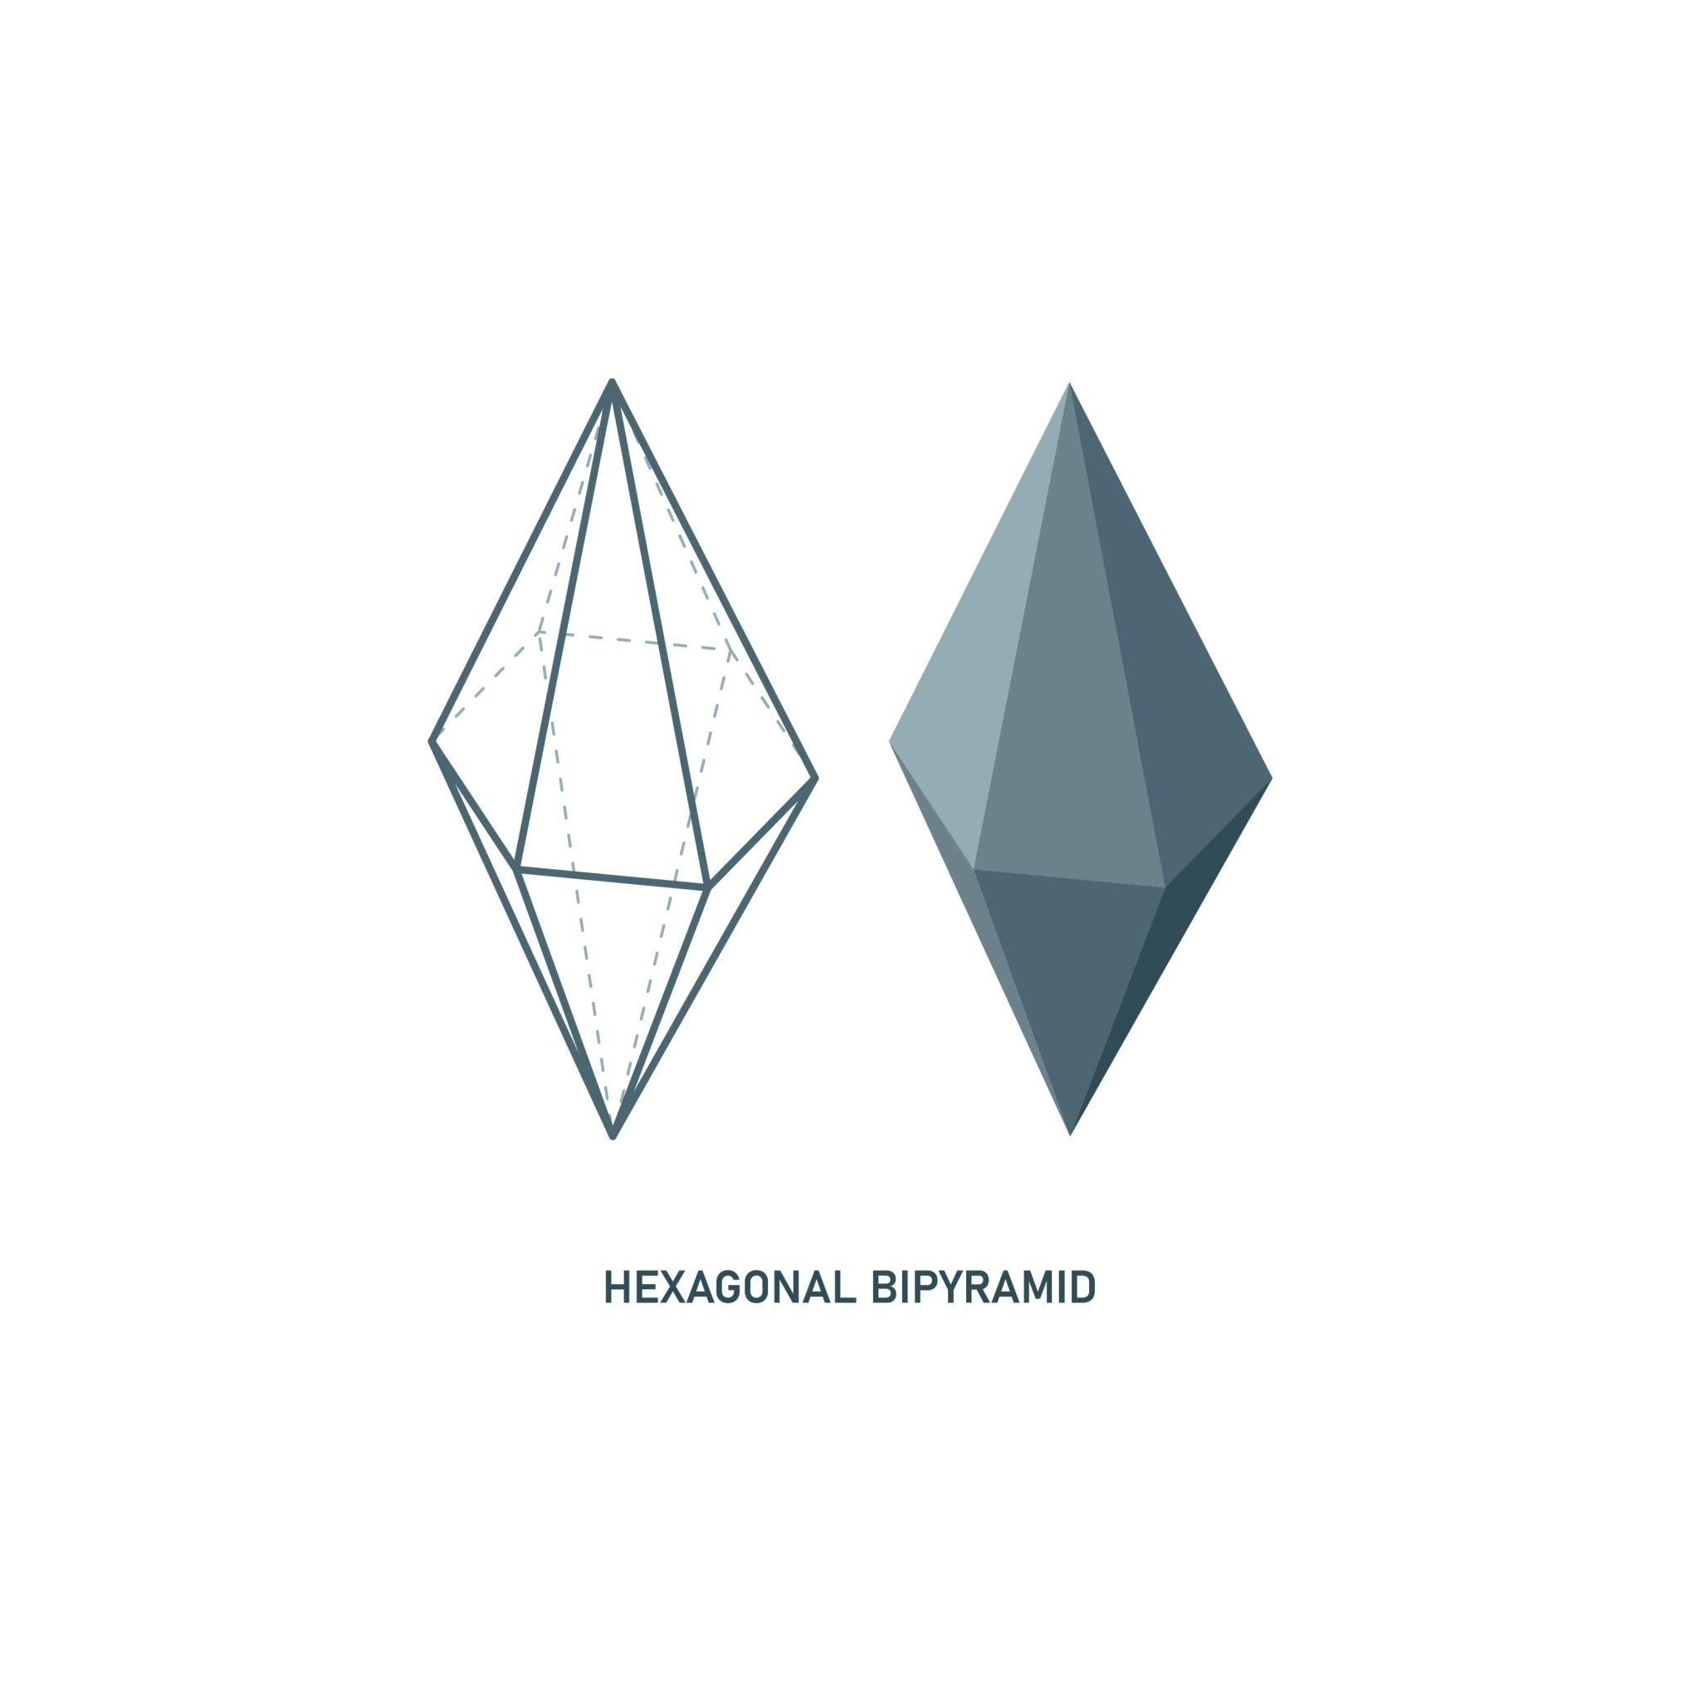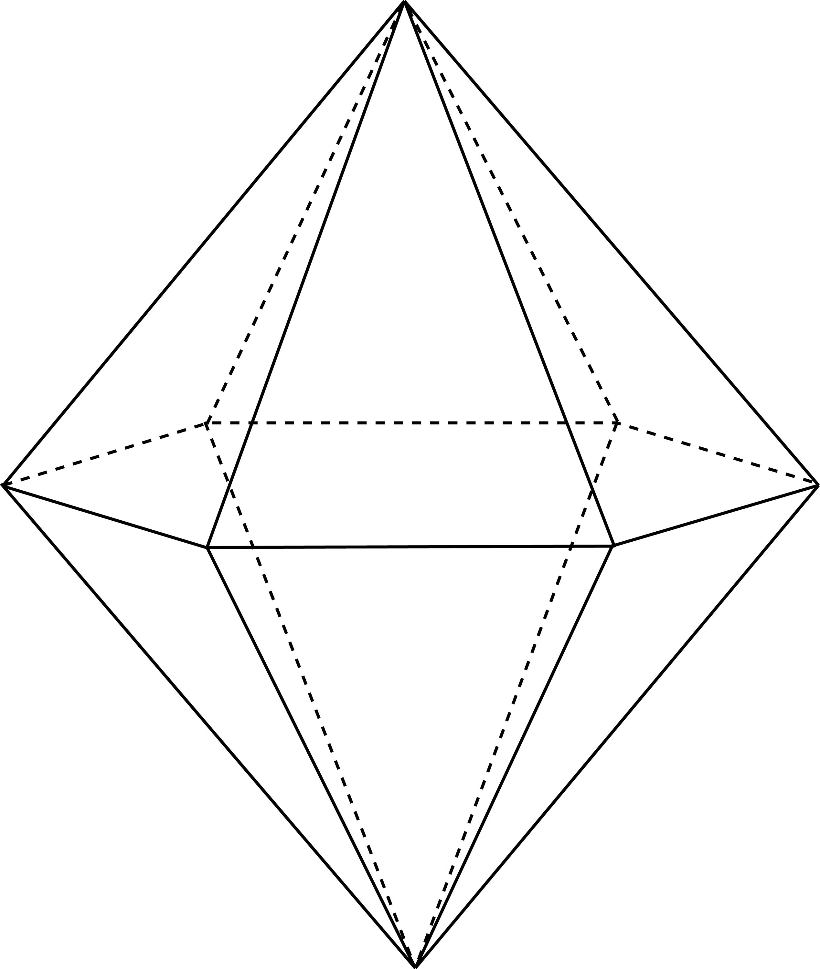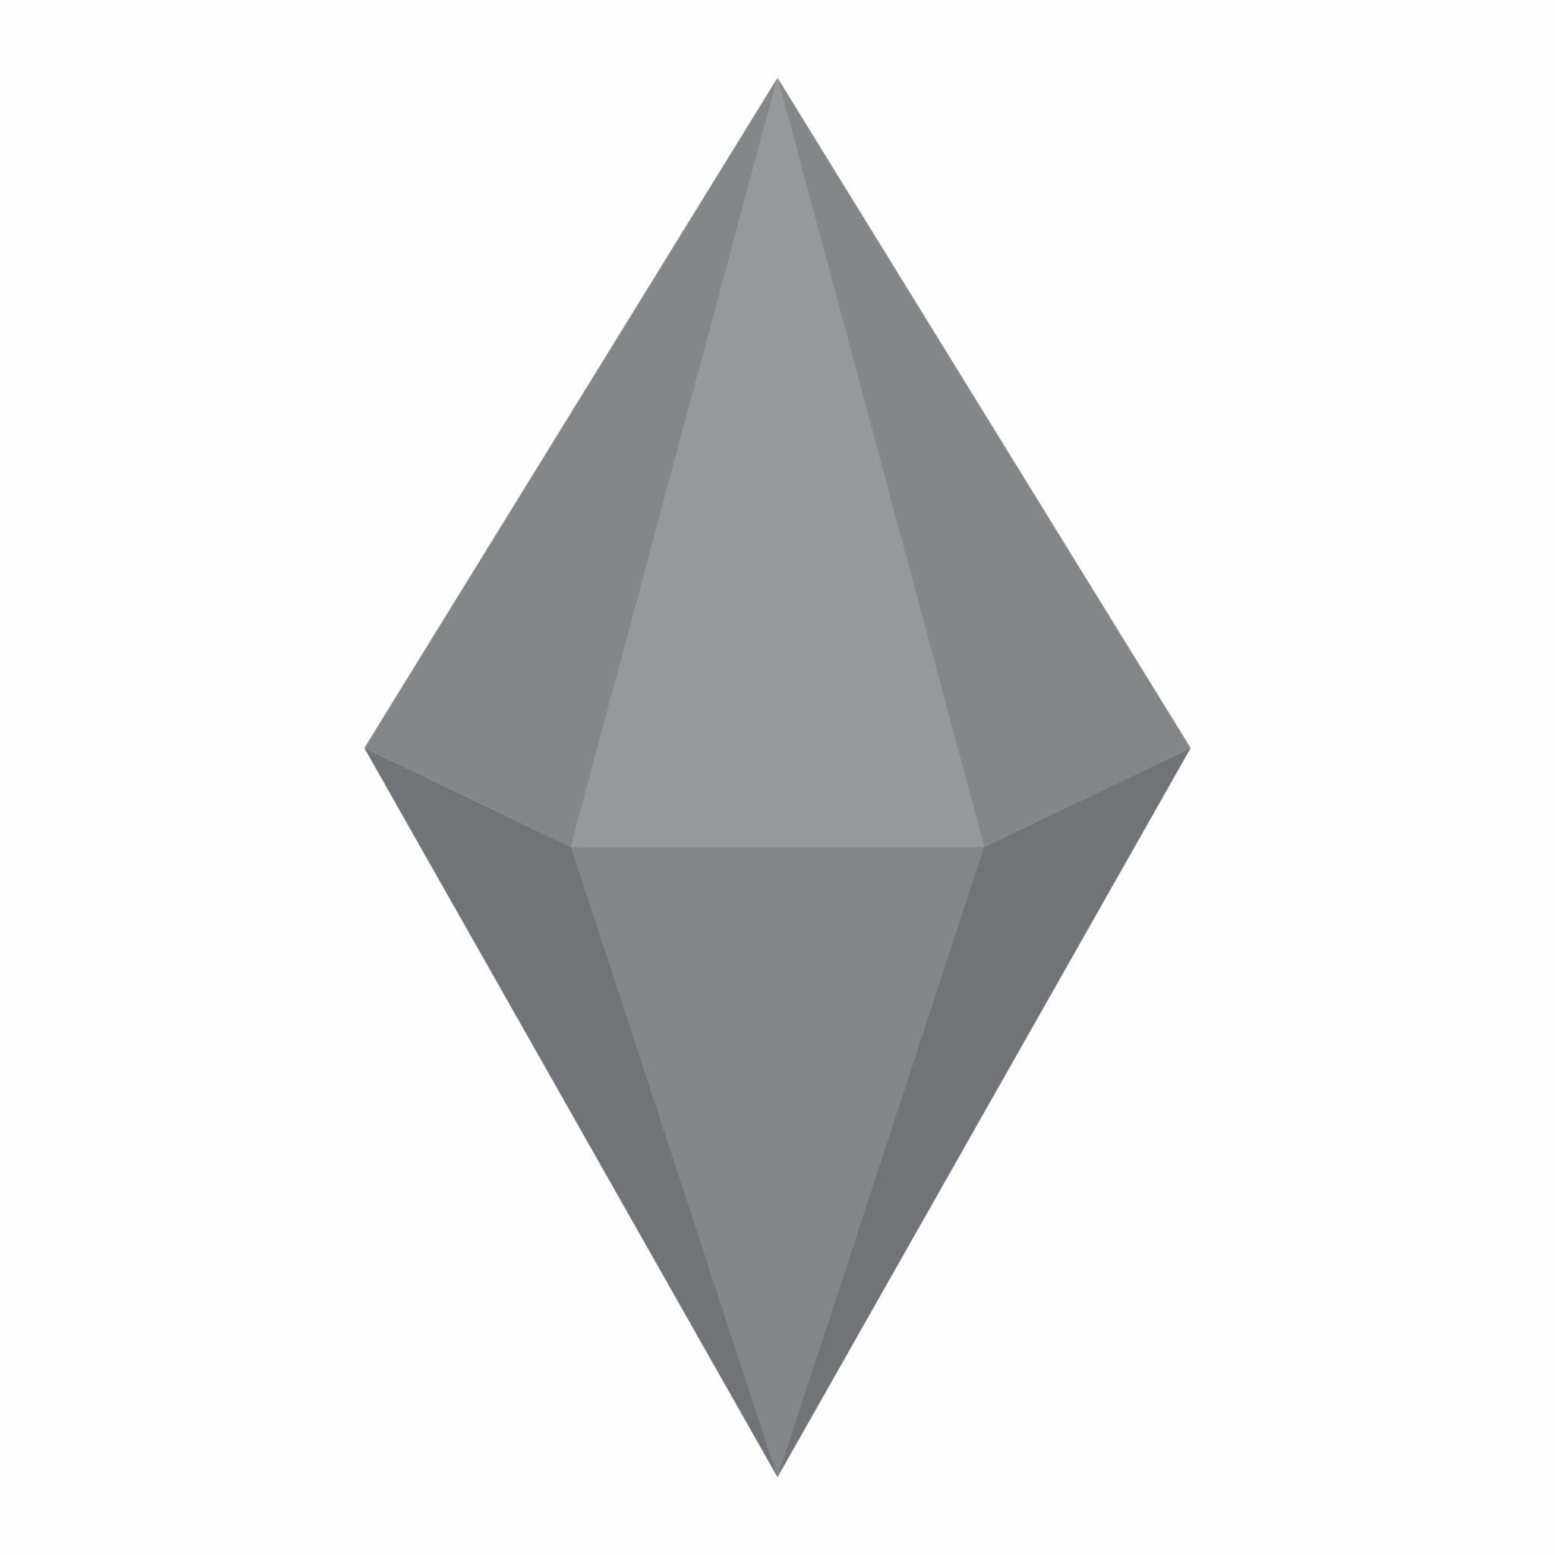

Simple Definition
# Source: AI Source: Provided by: [Data Path: Persons Table -> ID Column: 1, Name_En Column: Motasem Essam] -> From: [ChatGPT] on [7/25/2026]
A hexagonal bipyramid is a solid made by joining two hexagonal pyramids base-to-base, creating a polyhedron with 12 triangular faces, 18 edges, and 8 vertices.

Geometric Structure
# Source: AI Source: Provided by: [Data Path: Persons Table -> ID Column: 1, Name_En Column: Motasem Essam] -> From: [ChatGPT] on [7/25/2026]
The hexagonal bipyramid has three main structural components:
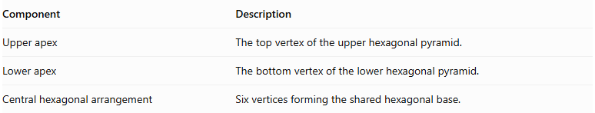
Component | Description
Upper apex | The top vertex of the upper hexagonal pyramid.
Lower apex | The bottom vertex of the lower hexagonal pyramid.
Central hexagonal arrangement | Six vertices forming the shared hexagonal base.
Both apexes are connected to all six vertices of the central hexagon.

Face Structure
# Source: AI Source: Provided by: [Data Path: Persons Table -> ID Column: 1, Name_En Column: Motasem Essam] -> From: [ChatGPT] on [7/25/2026]
A hexagonal bipyramid has 12 external triangular faces.
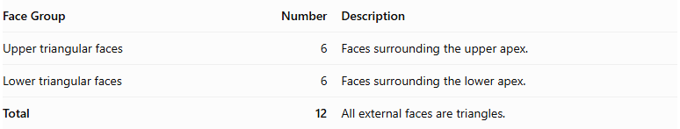
Face Group | Number | Description
Upper triangular faces | 6 | Faces surrounding the upper apex.
Lower triangular faces | 6 | Faces surrounding the lower apex.
Total | 12 | All external faces are triangles.
The common hexagonal base is internal, so it is not counted as an external face.

Edge Structure
# Source: AI Source: Provided by: [Data Path: Persons Table -> ID Column: 1, Name_En Column: Motasem Essam] -> From: [ChatGPT] on [7/25/2026]
The solid has 18 edges, divided into three groups:
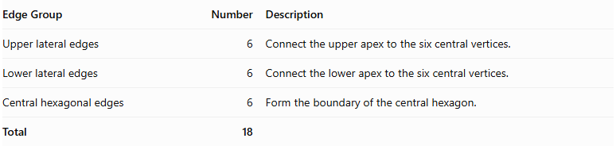
Edge Group | Number | Description
Upper lateral edges | 6 | Connect the upper apex to the six central vertices.
Lower lateral edges | 6 | Connect the lower apex to the six central vertices.
Central hexagonal edges | 6 | Form the boundary of the central hexagon.
Total | 18

Vertex Structure
# Source: AI Source: Provided by: [Data Path: Persons Table -> ID Column: 1, Name_En Column: Motasem Essam] -> From: [ChatGPT] on [7/25/2026]
A hexagonal bipyramid has 8 vertices.
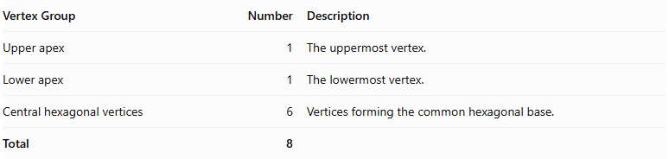
Vertex Group | Number | Description
Upper apex | 1 | The uppermost vertex.
Lower apex | 1 | The lowermost vertex.
Central hexagonal vertices | 6 | Vertices forming the common hexagonal base.
Total | 8

Mathematical Properties
# Source: AI Source: Provided by: [Data Path: Persons Table -> ID Column: 1, Name_En Column: Motasem Essam] -> From: [ChatGPT] on [7/25/2026]
For a hexagonal bipyramid:
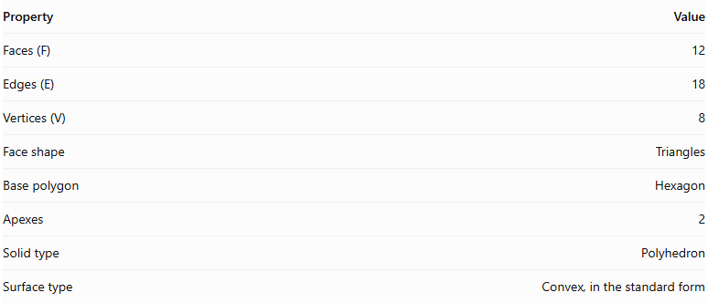
Property | Value
Faces (F) | 12
Edges (E) | 18
Vertices (V) | 8
Face shape | Triangles
Base polygon | Hexagon
Apexes | 2
Solid type | Polyhedron
Surface type | Convex, in the standard form
It satisfies Euler's polyhedron formula:
$$V-E+F=2$$
$$8-18+12=2$$

Face Incidence
# Source: AI Source: Provided by: [Data Path: Persons Table -> ID Column: 1, Name_En Column: Motasem Essam] -> From: [ChatGPT] on [7/25/2026]
In the standard hexagonal bipyramid:
- Each apex is shared by 6 triangular faces.
- Each central hexagonal vertex is shared by 4 triangular faces.

Surface Area and Volume

Surface Area
# Source: AI Source: Provided by: [Data Path: Persons Table -> ID Column: 1, Name_En Column: Motasem Essam] -> From: [ChatGPT] on [7/25/2026]
The total surface area is the sum of the areas of the twelve external triangular faces.
$$SA=6A_{u}+6A_{l}$$
Where:
- $A_{u}$ = area of one upper triangular face.
- $A_{l}$ = area of one lower triangular face.
If the upper and lower pyramids are congruent:
$$SA=12A_{t}$$
For a regular hexagonal bipyramid with identical triangular faces, where each triangle has base side length $s$ and slant height $l$:
$$SA=12(\frac{1}{2}sl)$$
$$\boxed{SA=6sl}$$

Volume
# Source: AI Source: Provided by: [Data Path: Persons Table -> ID Column: 1, Name_En Column: Motasem Essam] -> From: [ChatGPT] on [7/25/2026]
The volume is the sum of the volumes of the two hexagonal pyramids.
$$V=\frac{1}{3}{Bh}_{u}+\frac{1}{3}{Bh}_{l}$$
Therefore:
$$\boxed{V=\frac{1}{3}B(h_{u}+h_{l})}$$
Where:
- $B$ = area of the common hexagonal base.
- $h_{u}$ = height of the upper pyramid.
- $h_{l}$ = height of the lower pyramid.
For a regular hexagonal base with side length $s$:
$$B=\frac{3\sqrt{3}}{2}s^{2}$$
Therefore:
$$\boxed{V=\frac{\sqrt{3}}{2}s^{2}(h_{u}+h_{l})}$$

Symmetry
# Source: AI Source: Provided by: [Data Path: Persons Table -> ID Column: 1, Name_En Column: Motasem Essam] -> From: [ChatGPT] on [7/25/2026]
A regular hexagonal bipyramid with congruent upper and lower pyramids has the following symmetries:
- Sixfold rotational symmetry: Rotation by ${60}^{∘}$ around the central axis maps the solid onto itself.
- Vertical reflection planes: Six planes pass through the central axis and the central hexagonal arrangement.
- Horizontal reflection plane: The central hexagonal plane reflects the upper half onto the lower half.
- Central inversion symmetry: Each point has a corresponding opposite point through the solid's center.
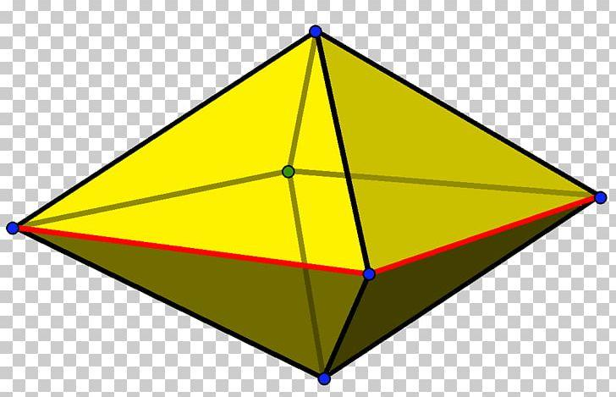

Relationship to Other Solids
# Source: AI Source: Provided by: [Data Path: Persons Table -> ID Column: 1, Name_En Column: Motasem Essam] -> From: [ChatGPT] on [7/25/2026]
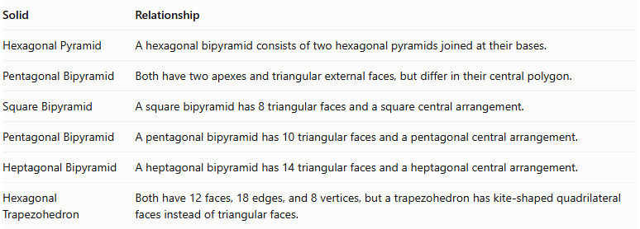
Solid | Relationship
Hexagonal Pyramid | A hexagonal bipyramid consists of two hexagonal pyramids joined at their bases.
Pentagonal Bipyramid | Both have two apexes and triangular external faces, but differ in their central polygon.
Square Bipyramid | A square bipyramid has 8 triangular faces and a square central arrangement.
Pentagonal Bipyramid | A pentagonal bipyramid has 10 triangular faces and a pentagonal central arrangement.
Heptagonal Bipyramid | A heptagonal bipyramid has 14 triangular faces and a heptagonal central arrangement.
Hexagonal Trapezohedron | Both have 12 faces, 18 edges, and 8 vertices, but a trapezohedron has kite-shaped quadrilateral faces instead of triangular faces.

Worked Examples

Example 1: Calculate the Number of Faces, Edges, and Vertices
# Source: AI Source: Provided by: [Data Path: Persons Table -> ID Column: 1, Name_En Column: Motasem Essam] -> From: [ChatGPT] on [7/25/2026]
Given: A hexagonal bipyramid has a hexagonal central arrangement.
For an $n$-gonal bipyramid:
$$F=2n, E=3n, V=n+2$$
Since $n=6$:
$$F=2(6)=12$$
$$E=3(6)=18$$
$$V=6+2=8$$
Answer:
- Faces = 12
- Edges = 18
- Vertices = 8

Example 2: Calculate the Volume
# Source: AI Source: Provided by: [Data Path: Persons Table -> ID Column: 1, Name_En Column: Motasem Essam] -> From: [ChatGPT] on [7/25/2026]
Given:
- Area of the hexagonal base: $B=72{ cm}^{2}$
- Upper pyramid height: $h_{u}=10 cm$
- Lower pyramid height: $h_{l}=8 cm$
Using:
$$V=\frac{1}{3}B(h_{u}+h_{l})$$
Substitute:
$$V=\frac{1}{3}(72)(10+8)$$
$$V=\frac{1296}{3}$$
$$\boxed{V=432{ cm}^{3}}$$

Constructing Hexagonal Bipyramid in Solid Geometry

Geometric Instruments Used
# Source: AI Source: Provided by: [Data Path: Persons Table -> ID Column: 1, Name_En Column: Motasem Essam] -> From: [ChatGPT] on [7/25/2026]
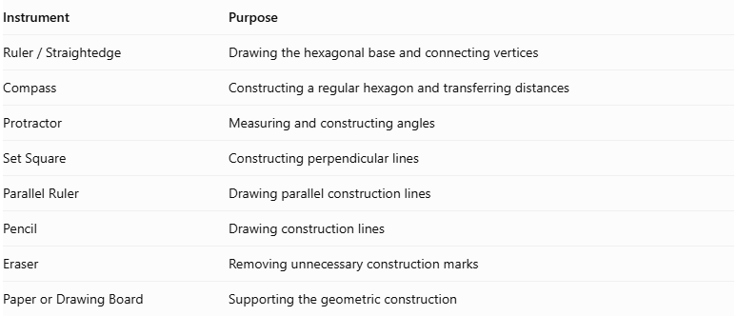
Instrument | Purpose
$$Ruler/Straightedge$$ | Drawing the hexagonal base and connecting vertices
Compass | Constructing a regular hexagon and transferring distances
Protractor | Measuring and constructing angles
Set Square | Constructing perpendicular lines
Parallel Ruler | Drawing parallel construction lines
Pencil | Drawing construction lines
Eraser | Removing unnecessary construction marks
Paper or Drawing Board | Supporting the geometric construction

Instrument-Based Construction Procedures

Constructing the Equatorial Hexagon
# Source: AI Source: Provided by: [Data Path: Persons Table -> ID Column: 1, Name_En Column: Motasem Essam] -> From: [ChatGPT] on [7/25/2026]
- Determine the required dimensions of the hexagonal base.
- Use a ruler and compass to construct a regular hexagon, if a regular base is required.
- Alternatively, construct an irregular hexagon with the specified side lengths and angles.
- Mark the six vertices as $A$, $B$, $C$, $D$, $E$, and $F$.
- Draw the six equatorial edges:
- $AB$
- $BC$
- $CD$
- $DE$
- $EF$
- $FA$

Locating the Two Apices
# Source: AI Source: Provided by: [Data Path: Persons Table -> ID Column: 1, Name_En Column: Motasem Essam] -> From: [ChatGPT] on [7/25/2026]
- Determine the intended positions of the two apices.
- Mark the upper apex as $P$.
- Mark the lower apex as $Q$.
- Position the two apices on opposite sides of the equatorial plane.
- For a symmetric hexagonal bipyramid, position both apices at equal perpendicular distances from the equatorial plane.

Connecting the Upper Apex
# Source: AI Source: Provided by: [Data Path: Persons Table -> ID Column: 1, Name_En Column: Motasem Essam] -> From: [ChatGPT] on [7/25/2026]
- Connect the upper apex $P$ to vertex $A$.
- Connect $P$ to vertex $B$.
- Connect $P$ to vertex $C$.
- Connect $P$ to vertex $D$.
- Connect $P$ to vertex $E$.
- Connect $P$ to vertex $F$.
These connections form six upper triangular faces:
- Triangle $PAB$
- Triangle $PBC$
- Triangle $PCD$
- Triangle $PDE$
- Triangle $PEF$
- Triangle $PFA$

Connecting the Lower Apex
# Source: AI Source: Provided by: [Data Path: Persons Table -> ID Column: 1, Name_En Column: Motasem Essam] -> From: [ChatGPT] on [7/25/2026]
- Connect the lower apex $Q$ to vertex $A$.
- Connect $Q$ to vertex $B$.
- Connect $Q$ to vertex $C$.
- Connect $Q$ to vertex $D$.
- Connect $Q$ to vertex $E$.
- Connect $Q$ to vertex $F$.
These connections form six lower triangular faces:
- Triangle $QAB$
- Triangle $QBC$
- Triangle $QCD$
- Triangle $QDE$
- Triangle $QEF$
- Triangle $QFA$

Completing the Hexagonal Bipyramid
# Source: AI Source: Provided by: [Data Path: Persons Table -> ID Column: 1, Name_En Column: Motasem Essam] -> From: [ChatGPT] on [7/25/2026]
- Draw all twelve external triangular faces.
- Identify the visible and hidden edges.
- Use solid lines for visible edges.
- Use dashed lines for hidden edges when necessary.
- Verify that both hexagonal pyramids share the same equatorial hexagon.
- Ensure that the shared hexagonal base is internal rather than an external face.

Constructing a Regular Hexagonal Bipyramid
# Source: AI Source: Provided by: [Data Path: Persons Table -> ID Column: 1, Name_En Column: Motasem Essam] -> From: [ChatGPT] on [7/25/2026]
- Construct a regular hexagonal equatorial base with side length $a$.
- Determine the center of the hexagon by constructing its diagonals.
- Construct a perpendicular line through the center of the hexagonal base.
- Position the upper and lower apices symmetrically on opposite sides of the equatorial plane.
- Select the required perpendicular height for both pyramidal portions.
- Connect each apex to all six hexagonal vertices.
- Verify that the twelve lateral faces are congruent isosceles triangles.

Constructing a Hexagonal Bipyramid Using a Net
# Source: AI Source: Provided by: [Data Path: Persons Table -> ID Column: 1, Name_En Column: Motasem Essam] -> From: [ChatGPT] on [7/25/2026]
- Construct twelve triangular faces.
- Arrange six triangles around the upper pyramidal portion.
- Arrange six triangles around the lower pyramidal portion.
- Ensure that corresponding edges have matching lengths.
- Fold the triangles to form the two hexagonal pyramidal portions.
- Join the corresponding edges to complete the hexagonal bipyramid.

Key Points
# Source: AI Source: Provided by: [Data Path: Persons Table -> ID Column: 1, Name_En Column: Motasem Essam] -> From: [ChatGPT] on [7/25/2026]
- A hexagonal bipyramid is formed by joining two hexagonal pyramids at their bases.
- It has 12 external triangular faces.
- It has 18 edges.
- It has 8 vertices.
- Its common hexagonal base is internal and is not counted as an external face.
- Its volume is the sum of the volumes of the two hexagonal pyramids.
- A regular symmetric hexagonal bipyramid has sixfold rotational symmetry.

Conclusion
# Source: AI Source: Provided by: [Data Path: Persons Table -> ID Column: 1, Name_En Column: Motasem Essam] -> From: [ChatGPT] on [7/25/2026]
The Hexagonal Bipyramid is a polyhedron formed by combining two hexagonal pyramids around a shared hexagonal base. It belongs to the family of $n$-gonal bipyramids and has 12 triangular faces, 18 edges, and 8 vertices.
Its defining characteristic is the six-sided central arrangement connecting the upper and lower apexes.

